**COMPUTER NETWORKS LAB**

**Designing and Simulation of Network Topology using Cisco Packet Tracer**

**WEEK 3**

**NAME: VISHWA MEHUL MEHTA**

**SRN: PES2UG20CS389**

**SECTION: F**

**DATE: 04/02/2022**

**Objectives:**

Using Cisco packet tracer understand the life of packet in internet. Create the following topology in packet tracer.

/--- DNS

A–R1—R2

\--- Web Server

Open the browser in A and access the web server using site name (not using IP Address). Traverse each packet (in simulation mode) and answer the following for each packet

Src IP, Dstn IP, Src Mac, Dstn MAC, pkt type (e.g. DNS, ARP, HTTP, TCP)

**Task 1:**

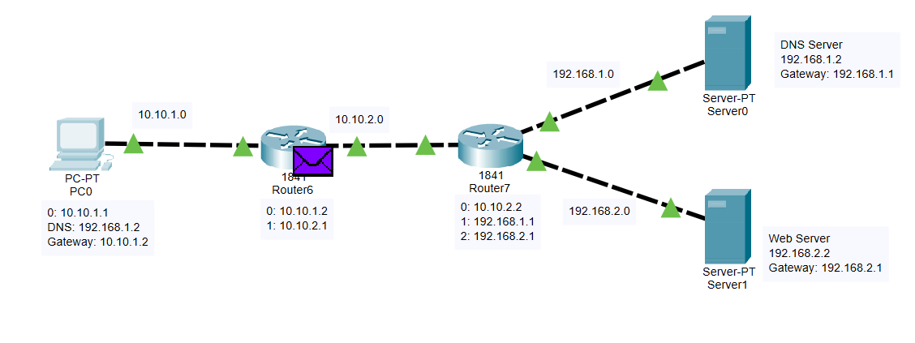

**PC & Router Configuration Details:**

**PC 0:**IP Address ---> 10.10.1.1  
Gateway ---> 10.10.1.2

**Router 6:**FastEthernet0/0 ---> 10.10.1.2  
FastEthernet0/1 ---> 10.10.2.1

**Router 7:**FastEthernet0/0 ---> 10.10.2.2  
FastEthernet0/1 ---> 192.168.1.1

Ethernet0/1/0 ---> 192.168.2.1

**Server 0:**IP Address ---> 192.168.1.2  
Gateway ---> 192.168.1.1

**Server 1:**IP Address ---> 192.168.2.2  
Gateway ---> 192.168.2.1

**Routing Table Entries:**

**Router Network Next Hop**Router6 192.168.1.0 10.10.2.2

192.168.2.0 10.10.2.2

Router7 10.10.1.0 10.10.2.1

------------------------------------------------------------

**OBSERVATIONS:**

1. When the request for the domain "google.com" was made then because DNS server did not have the address in the cache hence the query took more time to resolve the page (access the page back to the client from the web server) than in the following request.

Time for 1st request: 0.030s

Time for 2nd request: 0.028s

2. The reason for such a difference in time in the 2 requests being that DNS upon the first request of the web-server from the client cached the DNS-name and the IP address in its local DNS cache and on the subsequent request again doesn't need to search for the web-server again.

3. The ARP packets flowing were only seen in the first DNS request and not in the subsequent request as because of the DNS cache. All other packets i.e. TCP, HTTP and DNS were seen in both the web-server requests.

4. The colour coding was observed in the simulation mode:

ARP: Green

HTTP: Purple

DNS: Brown

TCP: Light green

